7-2 App Launch Plan

Southern New Hampshire University

Professor Jerome DiMarzio

Student: Tyanna Prince

04/14/2023

I chose the Inventory app as the app I developed throughout this course. The application’s goal is to track a user’s inventory using mobile devices such as a phone or tablet. The application allows its users to experience real time inventory storage on the go. The App was designed to run on android devices only. However, in the future I would like to make it accessible on other devices such as iOS devices. When the app is opened it displays a login screen where the user can enter their email address and password, register, or if the user has an account but has forgotten their password they can click forgot password to follow the steps to reset their password.

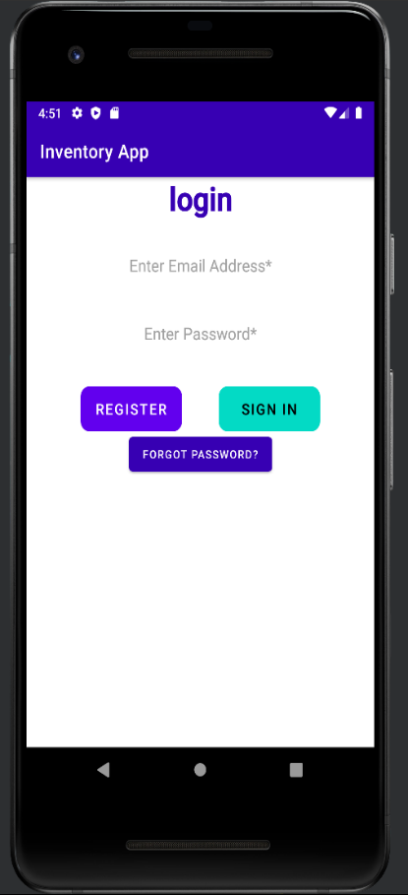

When the user registers and enters the required information, the app will verify all fields have valid information. If the user left a field empty or it’s determined a field is not valid an error message will pop up allowing the user to correct it. If the information is determined to be valid the app will then save the data provided in the UsersDatabase.DB. The app will then return the user to the Login screen to proceed to login to their newly created account.

**The Database**

For the security of the user the app uses two databases. The first is the User Database and the second is the Items Database. The User Database holds the user’s login information such as the name, phone, password, and email. The item database holds the user’s inventory with four columns. The item id, email, description of the item, and the amount of that item they have. I included the UserSQLiteHelper which is used by CRUD as well as the ItemSQLiteHelper. Once the user signs into their account the item activity will then display. This is where the user adds, deletes, or edits their inventory items. The user can also disable or enable SMS notifications on this screen. The database is only in a persistent state when the application is active.

**Description and Icon**

The description of the app will go somewhere along the lines of:

“This inventory app helps track your inventory using an android device on the go. The item list helps users manage their inventory in one location from anywhere in the world. Featuring real-time viewing of inventory.”

The icon for the app would contain a bar code simulating the scan of items and maybe a list with check marks. It would need to be colorful and vibrant to catch the audience’s attention. By doing so this would give a clear idea for the purpose of the application.

**API Version**

The application was developed using API 28 which can be used by 99% of android devices. This means the application can be used on both newer android devices as well as older ones.

**Permissions**

The implementation of SMS notifications allows the user to be alerted if any changes to inventory occur. It also asks for authorization of the devices SMS API. This can be disabled or enabled at any time. This is the only current permissions that are enabled in the app currently.

**Monetization**

The application in its current state is basic so my plan is to publish it for users to use free of charge. One a user base has been established over time, the app can then be updated and improved with better features. We would send emails to users asking for their opinions and concerns about the app. With enough feedback I would adjust, delete, and add features based on the users needs and wants. Once the app has more features and is being used often it can then be changed to a one-time fee app.